Inferential Statistics:
Strong correlations exist in white wines between density and alcohol with an r squared value of .65 and density and residual sugar with an r squared value of 0.7. No strong correlations can be found in the physiocochemical properties of red although ph and fixed acidity have a r squared of 0.47, as well as citric acid and fixed acidity have an r dsquared value of 0.47. The rest of both heatmaps is relatively colorless showing that most physiocochemical properties are independent of each other.
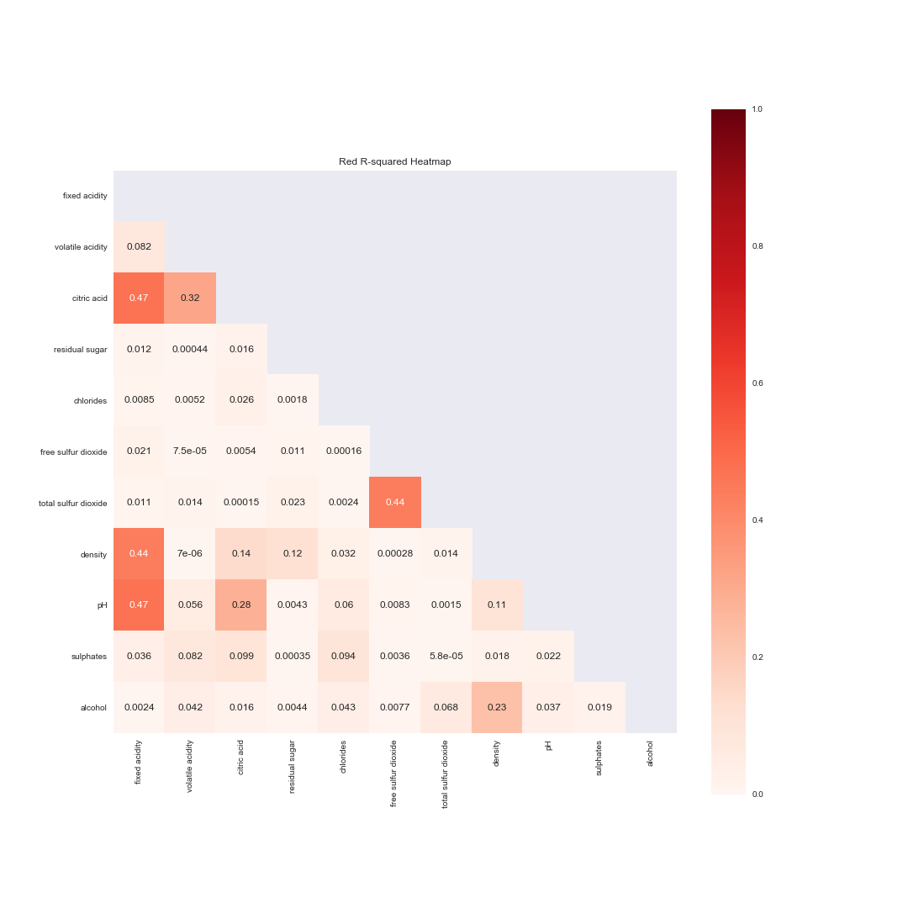
After grouping the wines into good and excellent quality groups and then performing null hypothesis tests between the groups on the physiocochemical properties some interesting ideas arose. First, the only accepted null hypothesis in white wines is citric acid and in red wines the two accepted null hypothesis are residual sugar (just barely) and ph. Interestingly, citric acid in white wines had the same mean for both the excellent and good quality groups but fixed acidity rejected the null hypothesis and showed axcellent and quality wines. Citric acids are part of what makes up the the total acidity in wine so this may mean one of the other fixed acids, tartaric, malic, or succinic, has a greater influence on white wine quality than citric (http://waterhouse.ucdavis.edu/whats-in-wine/fixed-acidity). Additionally, fixed acids and citric acid are not highly correlated in white wines so perhaps citric acids are even less significantly related to white wine quality. Each of the rejected null hypothesis test showed extremely significant p-values in both red and white wines and displays that there are differences in means of physiocochemical properties between good and excellent quality wines. Lastly, when looking at similarities between red and white wine properties, the shared rejected null hypothesis for both types are fixed acidity, volatile acidity, chlorides, free sulfer dioxide, total sulfer dioxide, density, sulphates, and alcohol. This means that any one of these properties may influence the quality of a wine in both red and white varieties.

